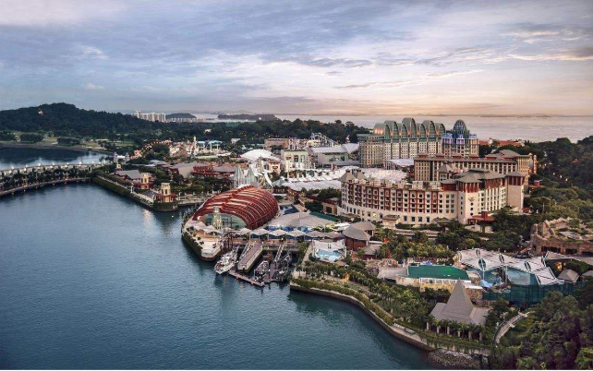Customer NameDocument Title

INTERNAL
: Resorts World at Sentosa Pte. Ltd.

RWS
TECHNICAL SPECIFICATION – INTERFACE

R2R-AP-I-002b, HR-SF-I-002, HR-SF-I-003, HR-SF-I-004, HR-SF-I-005 – Consolidated TS for S4HANA to NRS and SuccessFactors

Contents
1 Document Organization 5
1.0 Document Log 5
1.1 Integration, Document Reference 5
2 Clean Core Compliance 6
3 Program Attributes 6
3.1 Selection Parameter / Filter 7
3.2 Validation 7
3.2.1 Selection Criteria validations 7
3.2.2 Interface parameter validations 7
3.2.3 Other validations 7
3.3 Authorization Requirements 8
3.4 Definition 8
3.5 Defined Fields 8
3.6 Procedure 8
3.7 Technical Flow Diagram 8
3.8 Processing Logic 8
3.8.1 Validation 8
3.8.2 Mapping 8
3.8.3 Error Handling 8
3.8.4 Custom DDIC Objects 8
3.8.5 Custom CDS View Entity Details 8
3.8.6 BRF+ Design 9
3.9 Reusable Code 9
3.10 File Attributes 9
3.11 Internal Tables 9
3.12 Messages 10
3.13 Selection Text 10
3.14 Text Elements 10
3.15 Subroutines 10
4 Interface List Output 11
4.1 Field Details 11
4.2 Layout 11
4.3 Interface List Header & Footer 11
5 Application logs/Monitoring 11
6 Assumptions in Technical Design 11
7 Open Issues in Technical Design 11
8 Unit Test Results 11
9 Related Documentation 11

Document Organization
This section provides details about this document, previous version(s) of this document and the document(s) referred.

Document Log
Following table mentions the version changes and the processer(s):
Version | Status | Date | Version Created by (Name/E-Mail/Company) | Role | Comments
1.0 | Draft | June 23, 2025 | Ridhima Aggarwal | Author | Initial Draft
 | Choose an item. | Click here to enter a date. |  | Choose an item.

Integration, Document Reference
N/A
S. No. | Referred Document Name | Referred Document Version | Referred Document URL (Optional)

Clean Core Compliance

Final Solution | Category | Comments
 | Choose an item.

Program Attributes
Program title | ZRFI_GL_OUTBOUND
Program Name | GL Account, MID, cost center to NRS
Program Type | Executable
Package | ZFI
Authorization Group
Type of Interface | Asynchronous
Mode of Execution | Online/Background/Online OR Background

Transaction Code | ZFI_GL_OI
Include Programs | ZRFI_GL_OUTBOUND_T01, ZRFI_GL_OUTBOUND_F01
Function Modules | CONVERSION_EXIT_ALPHA_INPUT, FIRST_DAY_IN_PERIOD_GET, LAST_DAY_IN_PERIOD_GET, CONVERSION_EXIT_ABPSP_OUTPUT
Message Class

Classes
Generic Classes / Utility Classes
AMDP Classes
Proxy Class
FEH action class
Basic IDoc type
IDoc extension
Custom IDoc segment(s)
AIF Function module
API Name
CDS Name
Behavior Definition
Behavior Implementation Class
Service Definition
Service Binding

Selection Parameter / Filter

Single Valued / Range | Mandatory | Value Help | Default Value | User Text
P_RB1 |  |  |  | GL Master
P_RB2 |  |  |  | Cost Centre Master
P_RB3 |  |  |  | Profit Center Master
P_RB4 |  |  |  | Company code master
P_RB5 |  |  |  | Profit Centre to cost Centre
P_RB6 |  |  |  | Internal Order
P_RB7 |  |  |  | Trading partner
P_RB8 |  |  |  | Merchant ID
P_RB9 |  |  |  | Open Posting Period in SAP
P_RB10 |  |  |  | WBS Element
P_INT1 |  |  |  | NRS Interface
P_INT2 |  |  |  | Success Factor Interface

Validation

Selection Criteria validations
NA

Interface parameter validations
NA

Other validations
NA

Authorization Requirements
NA

Definition
  - Purpose
The purpose of this interface is to update COA master data from S/4HANA to NRS.
- This is an outbound interface from S/4HANA
- COA masters are created in S/4HANA
- The file contains data such as GL account, profit center, cost center etc. Detailed listing of fields required by sub-system and data mapping from SAP COA master to NRS are described in below sections
- This interface is executed daily, and the whole master data will be selected. The table will be overwritten with the new list from SAP S4HANA.
- Whole master data will be interfaced, so that data in NRS will be consistent with S4 data
  - Responsibility
S/4HANA
- Extraction based on agreed layout and file format.
- The file contains S/4 values.
- CPI places the file in csv format in the designated folder on the MFT server.
- File is picked up by NRS system and data is consumed
- The IT Department can also choose ad-hoc file generation.
NRS
- The values received will be in NRS formats Format. (to be confirmed)
- It is sub-system responsibility to built necessary validations and consume the data
- The Custom program in S/4 can be used to perform ad-hoc generation of the file into NRS (can be used, to handle error scenarios)

Procedure
- Run the transaction ZFI_GL_OI. Below mentioned selection screen will be opened.
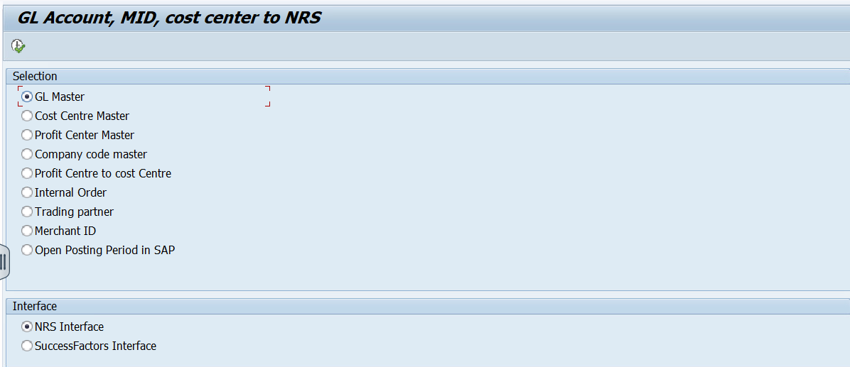
- Depending on the selection of Interface Data will be transferred to either NRS system or Success Factor.
- if Radio button NRS Interface is selected below mentioned data can be transferred to NRS System.
  - GL Master
  - Cost Centre Master
  - Profit Centre Master
  - Company code Master
  - Profit Centre to Cost Centre
  - Internal Order
  - Trading Partner
  - Merchant ID
  - Open Posting Period in SAP
- If Radio Button SuccessFactors Interface is selected below mentioned data can be transferred to SuccessFactors.
  - Cost Centre Master
  - Profit Center Master
  - Profit Center to Cost Centre
  - Internal order
  - WBS Element
- All the Data will be sent to CPI and the CPI will create a file and send it to respective system.
- Below are the WRICEF’s covered in the TS and all the Logic under section processing logic is explained as per below details:
Index Under Section 3.7 | Interface | WRICEF
3.7 (A) | GL Master | R2R-GL-I-02b
3.7 (B) | Cost Centre Master | R2R-GL-I-02b / HR-SF-I-002
3.7 (C) | Profit Centre Master | R2R-GL-I-02b
3.7 (D) | Company Code Master | R2R-GL-I-02b
3.7 (E) | Profit Centre to Cost Centre | R2R-GL-I-02b / HR-SF-I-003
3.7 (F) | Internal Order | R2R-GL-I-02b / HR-SF-I-004
3.7 (G) | Trading Partner | R2R-GL-I-02b
3.7 (H) | Merchant ID | R2R-GL-I-02b
3.7 (I) | Open Posting Period in SAP | R2R-GL-I-02b
3.7 (J) | WBS Element | R2R-GL-I-02b / HR-SF-I-005

Technical Flow Diagram
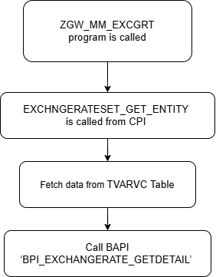

Processing Logic
Run transaction ZFI_GL_OI. Program ZRFI_GL_OUTBOUND will be called as per the radio button selected. Find the below logic in detail as per WRICEF.
3.7 (A) GL Master – WRICEF (R2R-GL-I-02b)
- Created Structure ZSFI_GL_MASTER_INT. 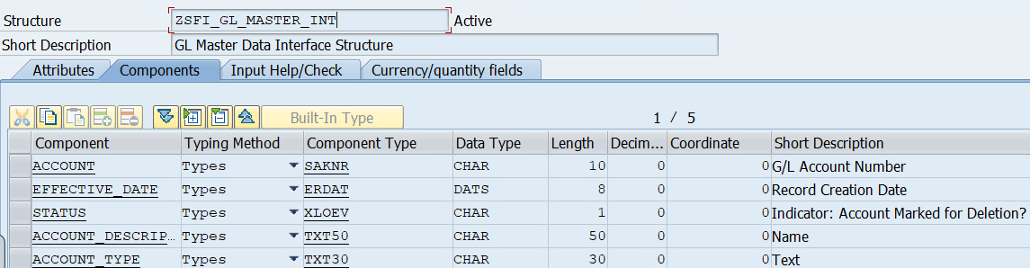
- Created Table Type ZRFI_GL_MASTER_INT for above structure.

- Fetch data from CDS – ZI_FI_GL_MASTER_O_INTERFACE.
- In the CDS fetch SKA1.SAKNR, SKA1.ERDAT, SKA1.XLOEV, SKAT.TXT50from table SKA1 left outer join table T077Z on T077Z.KTOKS = SKA1.KTOKS and T077Z.KTOPL = ‘GCOA’ and T077Z.SPRAS = $SESSION.SYSTEM_LANGUAGE, left outer join table SKAT on SKAT.SAKNR = SKA1.SAKNR and SKAT.SPRAS = $SESSION.SYSTEM_LANGUAGE where KTOPL = ‘GCOA’.
- Pass the fetched data in the Proxy class. For Proxy creation see the below logic.
  - Created Function Group ZFI_FG_GL_INTERFACE and Function Module Z_FI_FM_GL_OUT_INTERFACE with Importing and Exporting Parameter of type ZRFI_GL_MASTER_INT
  - Created a Web Service ZFI_WS_GL_OUT_INT for the above Function Module
  - Created Service Consumer ZCO_ZFI_WS_GL_OUT_INT for above mentioned Web Service.
  - Pass the Logical Port ZFI_PORT_GL in above mentioned consumer and pass the data in the proxy generated FM ZFI_FM_GL_OUT_INTERFACE.
3.7 (B) Cost Centre Master – WRICEF (R2R-GL-I-02b / HR-SF-I-002)
- Created Structure ZSFI_CC_MASTER_INT
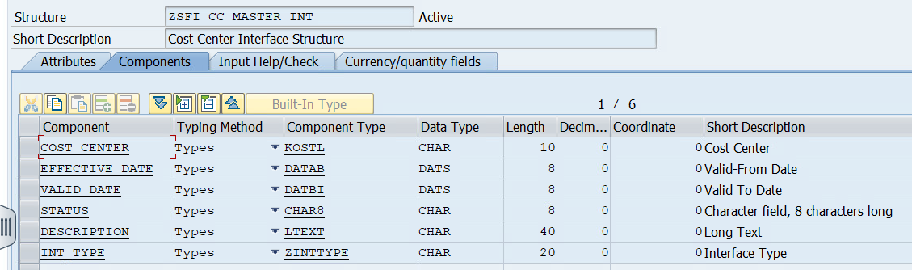
- Created Table Type ZTFI_CC_MASTER_INT for above mentioned Structure
- Fetch data from CDS – ZI_FI_CC_MASTER_O_INTERFACE.
- In the CDS fetch CSKS.KOSTL, CSKS.DATAB, CSKS.DATABI, CSKS.PRCTR, CSKT.LTEXT from table CSKS left outer join table CSKT on CSKT.KOSTL = CSKS.KOSTL and CSKT.DATBI = CSKS.DATBI, CSKT.KOKRS = CSKS.KOKRS and CSKT.SPRAS = $SESSION.SYSTEM_LANGUAGE.
- If Radio Button SuccessFactors (P_INT2) is selected from Selection Screen then pass value in INT_TYPE = SuccessFactors else NRS.
- If SuccessFactors is selected check the value of DATBI = 31.12.9999 then Status is ‘Active’ else Status = ‘Inactive’ and DATBI = actual date fetched from CSKS + 1.
- If NRS is selected pass Status as ‘Active’ if CSKS.DATBI > System date else ‘Inactive’.
- Pass the fetched data in the Proxy class. For Proxy creation see the below logic.
  - Created Function Group ZFI_FG_GL_INTERFACE and Function Module Z_FI_FM_CC_OUT_INTERFACE with Importing and Exporting Parameter of type ZTFI_CC_MASTER_INT
  - Created a Web Service ZFI_WS_CC_OUT_INT for the above Function Module
  - Created Service Consumer ZCO_ZFI_WS_CC_OUT_INT for above mentioned Web Service.
  - Pass the Logical Port ZFI_PORT_CC in above mentioned consumer and pass the data in the proxy generated FM ZFI_FM_CC_OUT_INTERFACE.
3.7 (C) Profit Centre Master – WRICEF (R2R-GL-I-02b)
- Created Structure ZSFI_PC_MASTER_INT
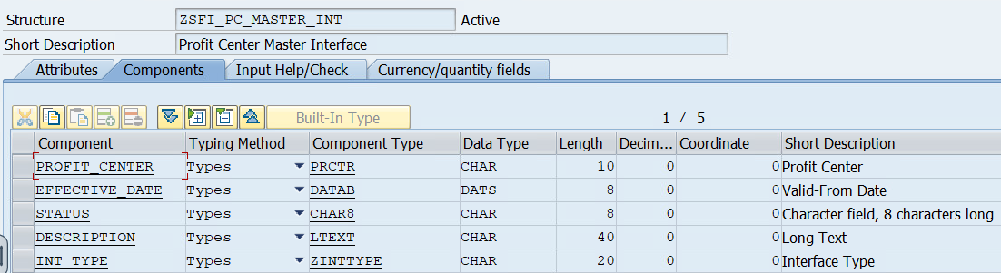
- Created Table Type ZTFI_PC_MASTER_INT for above mentioned Structure
- Fetch data from CDS – ZI_FI_PC_MASTER_O_INTERFACE.
- In the CDS fetch CEPC.PRCTR, CEPC.DATAB, CEPC.DATABI, CEPC.LTEXT from table CEPC left outer join table CEPCT on CEPCT.PRCTR = CEPC.PRCTR and CEPCT.DATBI = CEPC.DATBI, CEPCT.KOKRS = CEPC.KOKRS and CEPCT.SPRAS = $SESSION.SYSTEM_LANGUAGE where CEPC.KORKS = ‘GENS’.
- If NRS is selected pass Status as ‘Active’ if CSKS.DATBI > System date else ‘Inactive’.
- Pass the fetched data in the Proxy class. For Proxy creation see the below logic.
  - Created Function Group ZFI_FG_GL_INTERFACE and Function Module Z_FI_FM_PC_OUT_INTERFACE with Importing and Exporting Parameter of type ZTFI_PC_MASTER_INT
  - Created a Web Service ZFI_WS_PC_OUT_INT for the above Function Module
  - Created Service Consumer ZCO_ZFI_WS_PC_OUT_INT for above mentioned Web Service.
  - Pass the Logical Port ZFI_PORT_PC in above mentioned consumer and pass the data in the proxy generated FM ZFI_FM_PC_OUT_INTERFACE.
3.7 (D) Company Code Master – WRICEF (R2R-GL-I-02b)
- Created Structure ZSFI_CO_MASTER_INT
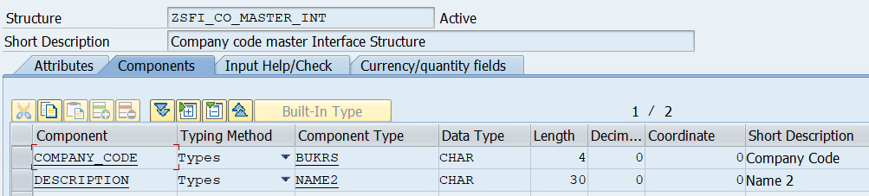
- Created Table Type ZTFI_CO_MASTER_INT for above mentioned Structure
- Fetch data from CDS – ZI_FI_CO_MASTER_O_INTERFACE.
- In the CDS fetch T001.BUKRS, T880.NAME2 from table T001 left outer join table T880 on T880.RCOMP = T001.BUKRS where T001.KTOPL = ‘GCOA’.
- Pass the fetched data in the Proxy class. For Proxy creation see the below logic.
  - Created Function Group ZFI_FG_GL_INTERFACE and Function Module Z_FI_FM_CO_OUT_INTERFACE with Importing and Exporting Parameter of type ZTFI_CO_MASTER_INT
  - Created a Web Service ZFI_WS_CO_OUT_INT for the above Function Module
  - Created Service Consumer ZCO_ZFI_WS_CO_OUT_INT for above mentioned Web Service.
  - Pass the Logical Port ZFI_PORT_CO in above mentioned consumer and pass the data in the proxy generated FM ZFI_FM_CO_OUT_INTERFACE.
3.7 (E) Profit Centre to Cost Centre – WRICEF (R2R-GL-I-02b / HR-SF-I-003)
- Created Structure ZSFI_PC_CC_MASTER_INT
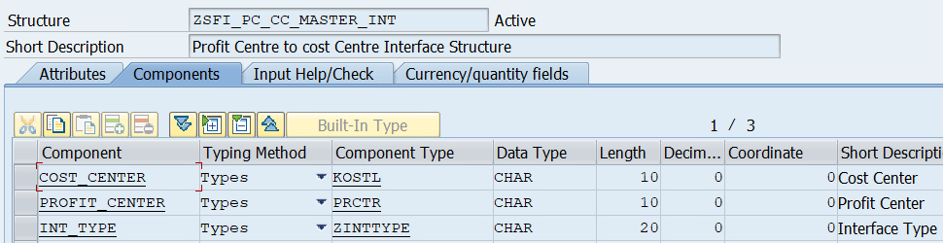
- Created Table Type ZTFI_PC_CC_MASTER_INT for above mentioned Structure
- Fetch data from CDS – ZI_FI_CC_MASTER_O_INTERFACE as mentioned in section 3.7 (B).
- If Radio Button SuccessFactors (P_INT2) is selected from Selection Screen then pass value in INT_TYPE = SuccessFactors else NRS.
- Pass the fetched data in the Proxy class. For Proxy creation see the below logic.
  - Created Function Group ZFI_FG_GL_INTERFACE and Function Module Z_FI_FM_PC_CC_OUT_INTERFACE with Importing and Exporting Parameter of type ZTFI_PC_CC_MASTER_INT
  - Created a Web Service ZFI_WS_PC_CC_OUT_INT for the above Function Module
  - Created Service Consumer ZCO_ZFI_WS_PC_CC_OUT_INT for above mentioned Web Service.
  - Pass the Logical Port ZFI_PORT_PC_CC in above mentioned consumer and pass the data in the proxy generated FM ZFI_FM_PC_CC_OUT_INTERFACE.
3.7 (F) Internal Order – WRICEF (R2R-GL-I-02b / HR-SF-I-004)
- Created Structure ZSFI_IO_MASTER_INT
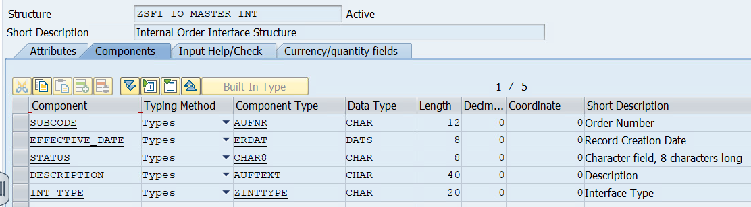
- Created Table Type ZTFI_IO_MASTER_INT for above mentioned Structure
- Fetch data from CDS – ZI_FI_IO_MASTER_O_INTERFACE.
- In the CDS fetch AUFK.AUFNR, AUFK.ERDAT, AUFK.KTEXT, AUFK.PHAS1, AUFK.PHAS2 from table AUFK.
- If AUFK.PHAS1 = ‘X’ and AUFK.PHAS2 = ‘X’ Pass ‘Status’ as ‘Active’ else ‘Inactive’.
- If Radio Button SuccessFactors (P_INT2) is selected from Selection Screen then pass value in INT_TYPE = SuccessFactors else NRS.
- Pass the fetched data in the Proxy class. For Proxy creation see the below logic.
  - Created Function Group ZFI_FG_GL_INTERFACE and Function Module Z_FI_FM_IO_OUT_INTERFACE with Importing and Exporting Parameter of type ZTFI_IO_MASTER_INT
  - Created a Web Service ZFI_WS_IO_OUT_INT for the above Function Module
  - Created Service Consumer ZCO_ZFI_WS_IO_OUT_INT for above mentioned Web Service.
  - Pass the Logical Port ZFI_PORT_IO in above mentioned consumer and pass the data in the proxy generated FM ZFI_FM_IO_OUT_INTERFACE.
3.7 (G) Trading Partner – WRICEF (R2R-GL-I-02b)
- Created Structure ZSFI_TP_MASTER_INT
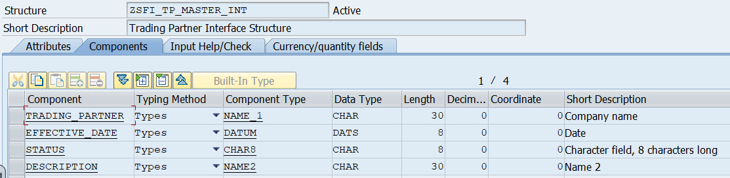
- Created Table Type ZTFI_TP_MASTER_INT for above mentioned Structure
- Fetch data from CDS – ZI_FI_TP_MASTER_O_INTERFACE.
- In the CDS fetch T880.RCOMP, T880.NAME2 from table T880.
- If AUFK.PHAS1 = ‘X’ and AUFK.PHAS2 = ‘X’ Pass ‘Status’ as ‘Active’ else ‘Inactive’.
- Pass Effective Date as ’01.01.2000’ and Status as ‘Active’.
- Pass the fetched data in the Proxy class. For Proxy creation see the below logic.
  - Created Function Group ZFI_FG_GL_INTERFACE and Function Module Z_FI_FM_TP_OUT_INTERFACE with Importing and Exporting Parameter of type ZTFI_TP_MASTER_INT
  - Created a Web Service ZFI_WS_TP_OUT_INT for the above Function Module
  - Created Service Consumer ZCO_ZFI_WS_TP_OUT_INT for above mentioned Web Service.
  - Pass the Logical Port ZFI_PORT_TP in above mentioned consumer and pass the data in the proxy generated FM ZFI_FM_TP_OUT_INTERFACE.
3.7 (H) Merchant ID – WRICEF (R2R-GL-I-02b)
- Created Structure ZSFI_MID_MASTER_INT
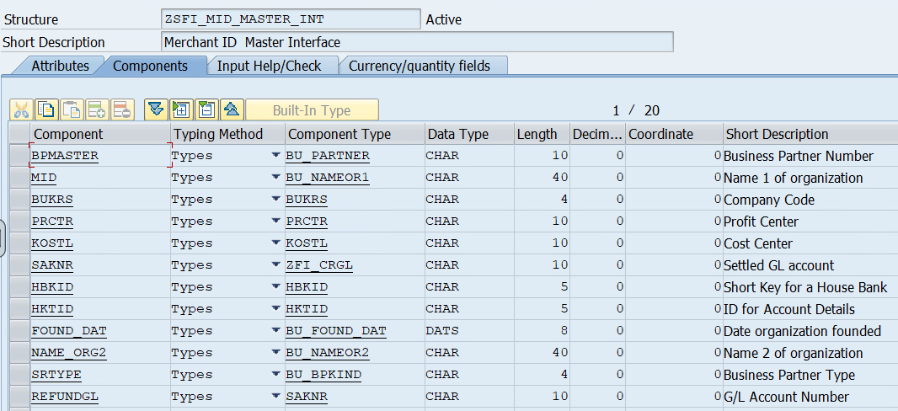
- Created Table Type ZTFI_MID_MASTER_INT for above mentioned Structure
- Fetch data from table ZFID_HB_PC_CC_GL.
- Pass the fetched data in the Proxy class. For Proxy creation see the below logic.
  - Created Function Group ZFI_FG_GL_INTERFACE and Function Module Z_FI_FM_MID_OUT_INTERFACE with Importing and Exporting Parameter of type ZTFI_MID_MASTER_INT
  - Created a Web Service ZFI_WS_MID_OUT_INT for the above Function Module
  - Created Service Consumer ZCO_ZFI_WS_MID_OUT_INT for above mentioned Web Service.
  - Pass the Logical Port ZFI_PORT_MID in above mentioned consumer and pass the data in the proxy generated FM ZFI_FM_MID_OUT_INTERFACE.
3.7 (I) Open Posting Period in SAP – WRICEF (R2R-GL-I-02b)
- Created Structure ZSFI_OP_MASTER_INT

- Created Table Type ZTFI_OP_MASTER_INT for above mentioned Structure
- Fetch BUKRS, MKOAR, PERIV, TO_DATE, FROM_DATE from TVARVC where Name = ‘ZFI_GL_OPENPERIOD’ data from table ZFID_HB_PC_CC_GL.
- Fetch BUKRS, MKOAR, FRYE1, FRP1, TOPE1, TOYE1 from T001b by passinf BUKRS and MKOAR fetched from TVARVC.
- Fetch FROM_DATE from FM ‘FIRST_DAY_IN_PERIOD_GET’. Concatenate fetched FROM_DATE and date from TVARVC and pass it in FROM_DATETIME.
- Fetch TO_DATE from FM ‘LAST_DAY_IN_PERIOD_GET’. Concatenate fetched TO_DATE and to date from TVARVC and pass it in TO_DATETIME.
- Pass the fetched data in the Proxy class. For Proxy creation see the below logic.
  - Created Function Group ZFI_FG_GL_INTERFACE and Function Module Z_FI_FM_OP_OUT_INTERFACE with Importing and Exporting Parameter of type ZTFI_OP_MASTER_INT
  - Created a Web Service ZFI_WS_OP_OUT_INT for the above Function Module
  - Created Service Consumer ZCO_ZFI_WS_OP_OUT_INT for above mentioned Web Service.
  - Pass the Logical Port ZFI_PORT_OP in above mentioned consumer and pass the data in the proxy generated FM ZFI_FM_OP_OUT_INTERFACE.
3.7 (J) WBS Element – WRICEF (HR-SF-I-005)
- Created Structure ZSFI_GL_WBS
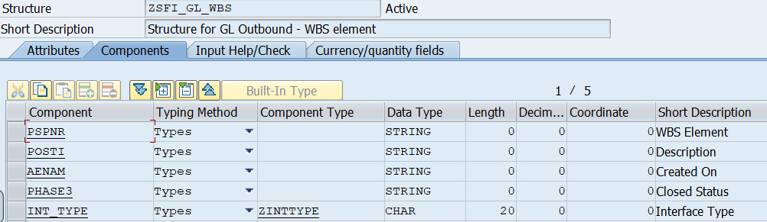
- Created Table Type ZTFI_GL_WBS for above mentioned Structure
- Fetch PSPNR, POST1, OBJNR, ERDAT from PRPS where BELKZ = ‘X’.
- Fetch OBJNR, STAT, UDATE and UTIME from JCDS where OBJNR = PRPS.OBJNR and INACT = ‘SPACE’.
- Fetch TXT30 from TJ02T by passing ISTAT = JCDS.STAT, SPRAS = SY.LANGU and TXT04 IN (‘REL’, ‘TECO’).
- If P_INT2 radio button is selected pass INT_TYPE = SuccessFactors.
- Pass the fetched data in the Proxy class. For Proxy creation see the below logic.
  - Created Function Group ZFI_FG_GL_INTERFACE and Function Module Z_FI_FM_WBS_OUT_INTERFACE with Importing and Exporting Parameter of type ZTFI_GL_WBS
  - Created a Web Service ZFI_WS_WBS_OUT for the above Function Module
  - Created Service Consumer ZCO_ZFI_WS_WBS_OUT for above mentioned Web Service.
  - Pass the Logical Port ZFI_PORT_WBS in above mentioned consumer and pass the data in the proxy generated FM ZFI_FM_WBS_OUT_INTERFACE.

Validation
N/A

Mapping
N/A

Error Handling
N/A

Custom CDS View Entity Details

Custom CDS entity Name | ZI_FI_GL_MASTER_O_INTERFACE
Primary View
Associated Views

Custom CDS entity Name | ZI_FI_CC_MASTER_O_INTERFACE
Primary View
Associated Views

Custom CDS entity Name | ZI_FI_PC_MASTER_O_INTERFACE
Primary View
Associated Views

Custom CDS entity Name | ZI_FI_IO_MASTER_O_INTERFACE
Primary View
Associated Views

Custom CDS entity Name | ZI_FI_TP_MASTER_O_INTERFACE
Primary View
Associated Views

Custom CDS entity Name | ZI_FI_CO_MASTER_O_INTERFACE
Primary View
Associated Views

BRF+ Design
N/A

Reusable Code
N/A

File Attributes
Same Details mentioned in corresponding CPI Technical Document.
File Type | Excel, ASCII, etc.?
Delimited / Fixed width | Comma, tab?
Header Record? | Provide layout
Footer Record? | Provide layout
Number of File Layouts and Description
File Layout(s) | Complete one per file layout (i.e., one for header records and one for detail records):

Messages
N/A
Message Class | Message ID | Message Text

Selection Text
Name | Description
P_INT1 | NRS Interface
P_INT2 | SuccessFactors Interface
P_RB1 | GL Master
P_RB2 | Cost Centre Master
P_RB3 | Profit Centre Master
P_RB4 | Company Code Master
P_RB5 | Profit Centre to cost centre
P_RB6 | Internal Order
P_RB7 | Trading Partner
P_RB8 | Merchant ID
P_RB9 | Open Posting Period in SAP
P_RB10 | WBS Element

Text Elements
Name | Text Description
000 | Selection
001 | Maintain TVARVC for ZFI_GL_OPENPERIOD
002 | Interface
003 | NRS
004 | SuccessFactors

Subroutines
Name | Description
CHECK_SELECTION_DISPLAY | For Selection Screen
SEND_GL_MASTER | Send GL Master Data to NRS
SEND_CC_MASTER | Send Cost Centre Data to NRS and SuccessFactors
SEND_PC_MASTER | Send Profit Centre Data to NRS
SEND_BC_MASTER | Send Company Code Data to NRS
SEND_PC_TO_CC | Send Profit Centre as per Cost Center to NRS and SuccessFactors
SEND_INT_ORDER | Send Internal Order Data to NRS and SuccessFactors
SEND_TR_PARTNER | Send Trading Partner Data to NRS
SEND_MERCH_ID | Send Merchant ID Data to NRS
SEND_CALANDER | Send Open Period Data to NRS
SEND_WBS | Send WBS data to SuccessFactors

Interface List Output

Field Details
[Please list the fields for output]

Layout
[Please list the sequence of the fields in which the output must be displayed?
Or embed Excel sheet layout.]

Interface List Header & Footer
[If deviation from the project defined header and footer is required mention Interface List Header and Report Footer]

Application logs/Monitoring
[Include Application log object, sub object details.]

Assumptions in Technical Design

Open Issues in Technical Design

Unit Test Results
[Please indicate the Unit Test Results that should be used to verify successful operations of the Interface]
[Document all technical scenarios associated with this development. Examples would include 1) testing an error-free run; 2) testing the exception processes; 3) testing the error handling.]
[Document all control scenarios associated with this development. Examples would include 1) Rounding of dollars and cents; 2) Audit trail processing; 3) Reconciliation reporting]
IMPORTANT: Provide instructions to reverse the actions performed so the test may be run again, or explain how to create new input data to the test.
Scenario # | Input Selection Criteria | Expected Result | Actual Test Pass/Fail
 |  |  | Choose an item.
 |  |  | Choose an item.
 |  |  | Choose an item.

Related Documentation
[Attach OSS notes, emails, download of existing report, etc.]

Template Version

Version | Status | Date | Version Created by | Reviewer | Approver | Comments
1.0 | Final | February 11, 2019 | Abhishek Nayak | Jagmeet Singh | Modak Gupta | Initial version created
2.0 | Final | Oct 18, 2023 | Ravish Ranka | Jagmeet Singh | Modak Gupta | Updates according to latest development guideline

